|  |
| --- |
|  |
| Faculty of Computers and Information Technology (FCIT) |
| Auto-attendants |
| Supervisor: Dr. Mohammad Naif Al-Atawi |
| Submitted in partial fulfillment of the requirements for the Degree of Bachelor of Information Technology |
| Academic Year: 2022/22 |

* **Abstract**

It is a mobile app for phones that facilitates many things that used to take a lot of time from the student and the Lecturer, and its main goal is to facilitate. Facilitate attendance and the absent and other things such as knowing the locations of the halls and teachers for each college and lecture to facilitate attendance in the fastest way to the hall or connected to the teacher’s offices‏

every student has the UniFinder app, and every hall has an ibeacon that holds the lecture info, and the hall number lecturer added by his student schedule, the beacon will sense the student who has the UniFinder app and match his University ID to the Students of this current lecture, if the University 10 matches the student of this current lecture, then his (present) if not then send notification. This hall does not match your course

* **Introduction**

for beginning let us review the problems, how much does the lecturer lose time for attendance, and sometimes he mistakes for another Student, but our project idea can solve it, what about the student they mistake things that the project can solve such as what is the proper hall, and is that my Course, if the project has reached for the highest compilation we can use it for things other than the university, such as Cafés, restaurants and touristic places, this project can have many ideas involving (area information, and sending it for the user).

* **Background to the project**

Given the importance of time in general for the student and the teacher in particular, and to take the maximum educational attainment

Our project focuses on saving time and facilitating many steps

* **Problem overview**

The college needs a way to facilitate the status of attendance and absence, full disclosure of halls and teachers, coordination between them, and the identification of teachers’ locations in all colleges

* **Project Objectives**
* Speed of attendance and absence
* Find out where the halls are
* Knowing where the teachers are

**Aims and Objectives**

Therefore, we are working on an application for university students to facilitate the connection and save time for students to find halls and teachers

Auto-attendance and timer for the duration of the student's attendance of the lecture

* **Advantages**
* 1- Attendance and absence for all students automatically.
* 2- Temporary for the duration of the student's attendance at the lecture.
* 3- Hall status, is there a lecture or not?
* 4- Fetching the information of the current hall, for example (the lecturer, the Lecturer start timer)
* 5- Hall dates and locations.
* 6- Print the student attendance record for only the lecturer.
* **Drawbacks**
* The Cost of Ibecon
* Does not specify the time if the Ibecon didn't indicate the student.
* If the student has his phone turned off, then his absent.
* If the student has his phone turned off in the middle of class time, then in state time, it will show less attendance time.
* **RELATED WORKS**
* **odoo**

This site has some points that are similar to our program, such as attendance management, but it lacks some features such as where the employee is located

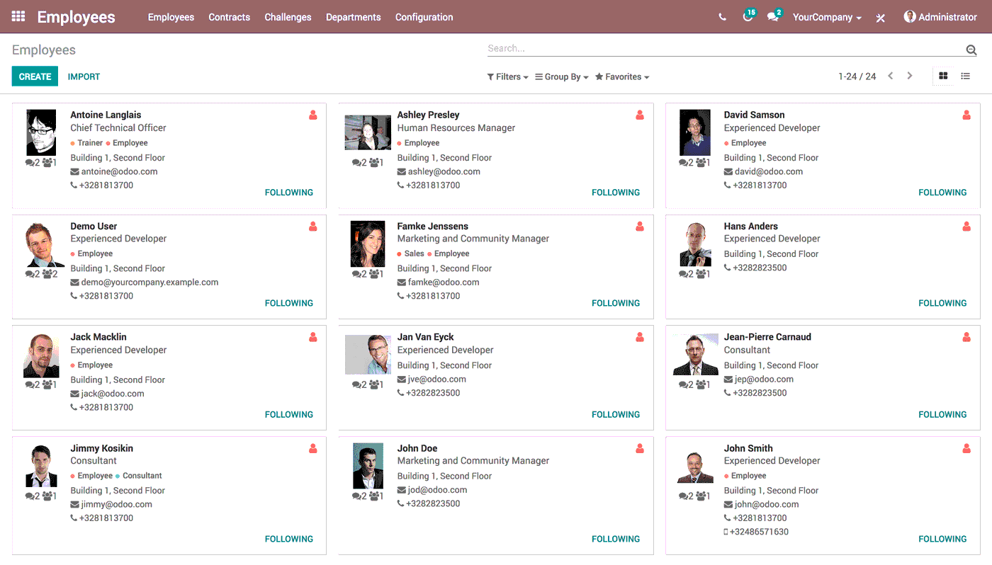

* **menaitech**

This application is similar to our application, but it does not have options to adjust times and other options such as delay, and also there is no option for the location of the hall.

* **Methodology**

We will use the agile methodology for the development of this project. The Agile methodology is an iterative development methodology that values human communication and feedback, adapting to change, and producing working results

The agile SCRUM method is used for the development of the software.

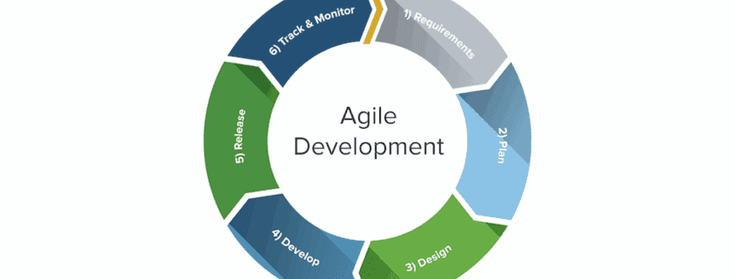

Students and Lecturers are involved in all the processes.

It allows managers to control the project.

Best model to detect and foresee hazards.

Best model to guarantee that the project runs successfully.

It is allowing team members to learn from one another's mistakes and grow together.

* **Requirements**

We will be able to derive the perfect understanding of requirements and analyses in this chapter and develop the software product. Stakeholder inputs and information gathered during the requirement-gathering stage are used as inputs in this step. There are two types of requirements: functional and non-functional requirements

Ibeacon in every hall to indicate the student who entered the hall.

Every student and lecturer has the app downloaded.

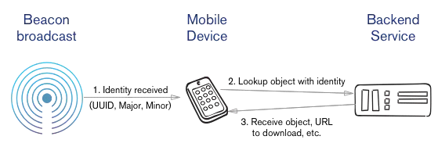

* **Functional Requirements**

Functional requirements are product features or functions that developers must implement to enable users to accomplish their tasks. This system has many functions that assist clinics with their processes and management,

For the software:

The administrator controls the accounts of the lecturer and the student (Create, Modify, Delete).

The administrator controls the lecturer and (Creates, Modifies, and Deletes).

The administrator controls the accounts of the student (Create, Modify, Delete).

The lecturer requests the auto-attendants.

The lecturer requests to print the state of the class which is (student attendant's time, students' attendance, and absent).

Students request the hall name.

Students request the current hall state which is (the subject of the class, Time of the class).

For the hardware:

Buying ibeacon device because we can't build an ibeacon from the ground zero.

Find ibecon that we can program not programmed by a company.

understand the student schedule to add it to the database.

* **Non-Functional Requirements**

The non-functional requirement is a requirement that specifies criteria that can be used to judge the operation of a system, rather than specific behaviors [6]. The non-functional requirement that will provide in this project is usability, that is mean is a measure of how well a specific user in a specific context can use a product to achieve a defined goal effectively, efficiently, and satisfactorily.

For the software:

To find an ibeacon device that allows us to program, we need to ask the company for permeation.

Connecting the ibeacon to the system coding.

Connecting the ibeacon to the database.

Building a server that holds all the students and lecturers.

For the hardware:

the cost of the ibeacon that we need every hall to have.

Ibeacon sensor range.

in case of hardware errors, we need to buy a new ibeacon.

dose the ibeacon stay on for timing the student attended.

* **Use Case Diagram**

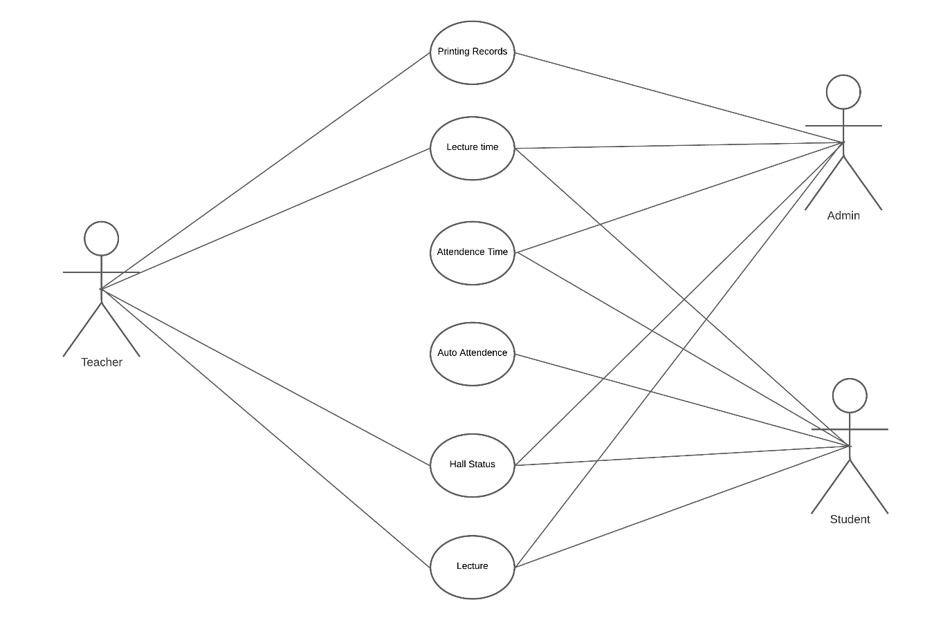

* **Sequence Diagram**

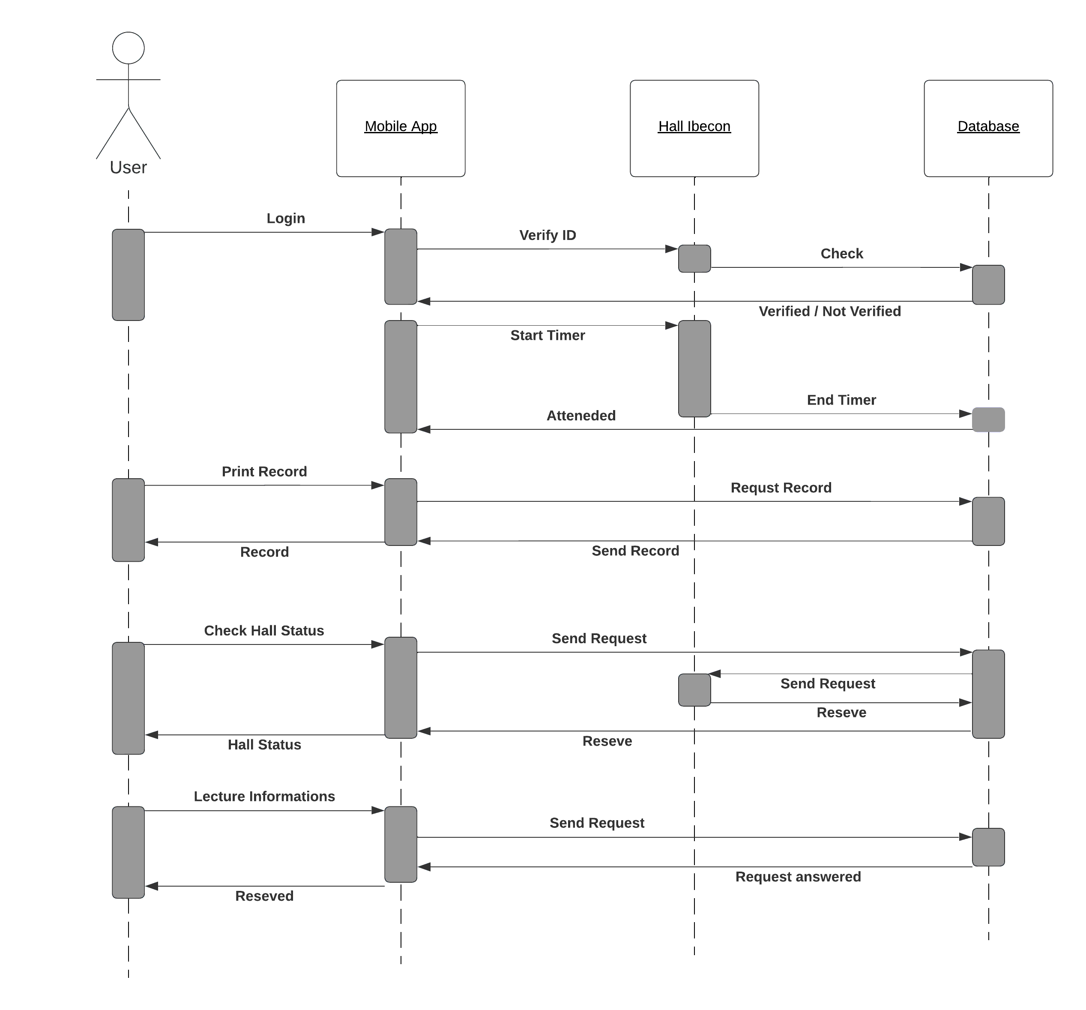

**Activity Diagram** 